# CS 255 System Design Document Template

## UML Diagrams

### UML Use Case Diagram

### UML Activity Diagrams

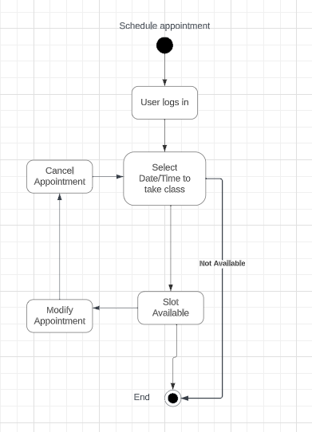

### UML Sequence Diagram

### UML Class Diagram

## Technical Requirements

Based on the system there are a few technical requirements. We can first look at the needed infrastructure including a database system with a recommended version being one on a cloud to reduce needed physical infrastructure. Users will require some form of internet-based device to connect to the system and log in to their account from either a phone or a computer. Administrators should have a working baseline of the system to aid students or instructors if technical issues or account issues present themselves. This is also based on the idea that Drive Pass will have one or more physical locations for students and instructors to meet and engage with one another and that staff will either be able to work remotely via the cloud-based system or in an office setting at the same location. I These are the technical requirements for the system that I identified.